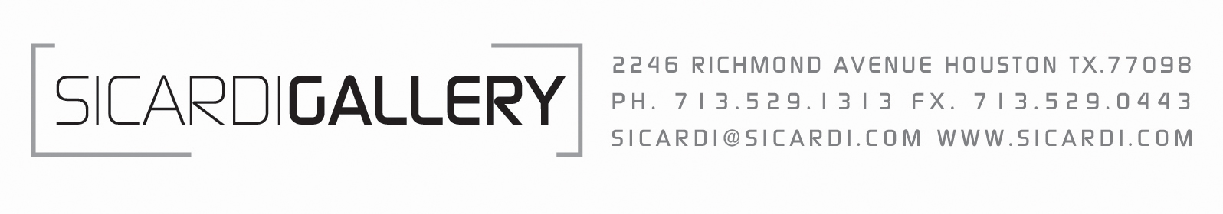

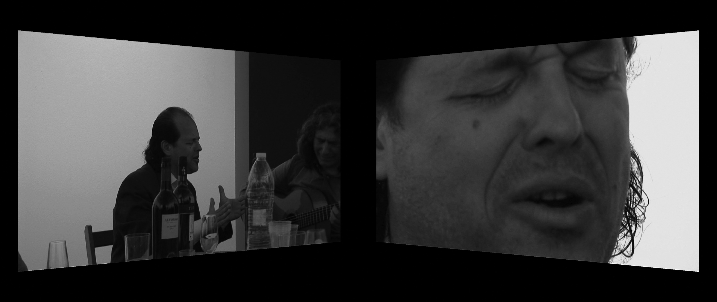

Dias & Riedweg, Cuarto de Cabales, 2010, two-channel video installation, 20 minutes

Sicardi Gallery
Dias & Riedweg: Peñas de pena

Sicardi Gallery is pleased to present “Peñas de pena,” an exhibition of new work by Dias & Riedweg. The opening will be held on Friday, September 10, 2010; there will be a cocktail reception with the artists from 6 to 9 p.m.

In Peñas de pena [Parties of Sorrow] the artists visualize the drama, beauty and music of traditional Flamenco, which endures today in modest peñas in Andalusia. One two-channel video installation, Cuadro de Cabales, focuses on four leading musicians, never before united. A single-channel video presents a fragile interview with another singer Antonio Agujetas. And a “Meta-Wall of Photographs” plays against the images of idols, musicians and associates that cover the walls of the actual peñas.

Robin Held, Deputy Director of Exhibitions at the Frye Art Museum in Seattle, has written a text for this show. She notes that Dias & Riedweg work with “social groups, self-defined or defined by others, often outside or at the edge of dominant culture [but avoid] stalking, seizure and visual domination.” Instead, they explore “shifting boundaries of inclusion and exclusion [and] play between different modes of language: theoretical and poetic, anecdote and analysis, nonsense and clarity, concept and metaphor, verbal and nonverbal.”

The artists will also be giving a lecture on Thursday, September 9, at 7 p.m. in the Freed Auditorium at the Glassell School of Art of the MFA Houston. Following the lecture, Dias & Riedweg will present “Moving Truck,” an ongoing mixed media project using the vehicle as a platform to confront and generate unexpected interactions with the audience. Earlier versions of “Moving Truck” have been seen in Brussels, New York City, Sao Paulo, Lisbon and Mexico City.

Maurício Dias (Brazil) and Walter Riedweg (Switzerland) form a team of artists based in Rio de Janeiro. They have worked together as Dias & Riedweg since 1993, using their backgrounds in the visual arts and performance to create collaborative interdisciplinary public art projects that rely on audience participation to energize public spaces. Dias & Riedweg have presented their projects at Documenta 12 (Kassel, Germany, 2007), the Venice Biennale (2007), InSite (San Diego-Tijuana, 2000) and the Sao Paulo Biennale (1998), among other venues.

For additional information about Dias & Riedweg, contact Sicardi Gallery at info@sicardi.com. For information on the lecture in Houston, check the Glassell Core Fellow website at www.core.mfah.org.

